Accessing List Elements:
List elements are accessed by providing the identifier and index of element inside square brackets. For example in following snippet arr is an identifier which points to a list.
arr = [1, True, “Pakistan” , 3.5, 9]
To access the element at Position 3 which is “Pakistan”, we write:
print (arr[2])
Please note that to access the position 3 we have provided index 2, because first element in Python list always starts with 0 (Zero) index.

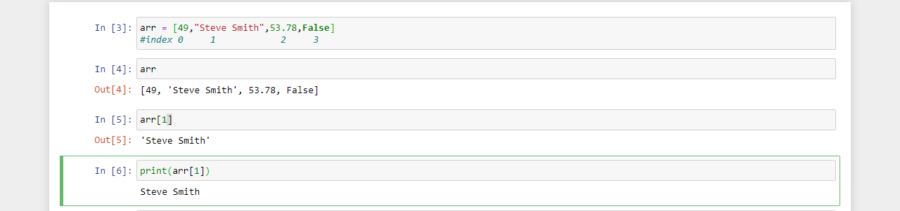
Adding value in List:
Python provides a function append() which adds the Value at the end of List.
For example RDX points to a list following snippet .
RDX = [1,-3, 4.5, 32, 0.2, 4.6]
To add a value 321 in the last we can do the following
RDX.append (321)
Now if we check the elements in list RDX we will get the following content.
[1, -3, 4.5, 32, 0.2, 4, 6, 321]
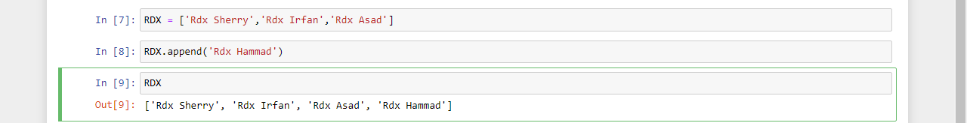
Searching / Finding value in list:
Python provides a function index () which returns the index of the first occurrence of the value. For example if RDX points to a list
RDX = [1, -3, 4.5, 32, 0.2, 4, 1]
To find a value 1 in the list we can do the following
RDX.index (1)
This call give the result 0 even you execute this line many times, the reason is by default this function starts searching from index 0 & stops when it finds first occurrence of the desired value.

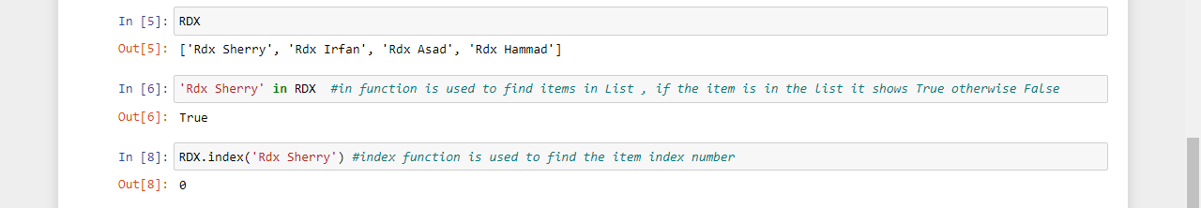
Slicing the element from list:
Python provides a very handy feature if you want to take a partial piece of list. Note that slicing operation copies elements from the original list hence returns a new list which is subset of the original list. Example syntax:
RDX = [1, 4, 3, 78, 23, 89]
print(RDX[1: 4]) #outputs = [4, 2, 78]

inclusive Exclusive
print(RDX[-2: -1] #outputs = [23]
print(RDX[1: :2]) #outputs = [4, 78, 23]
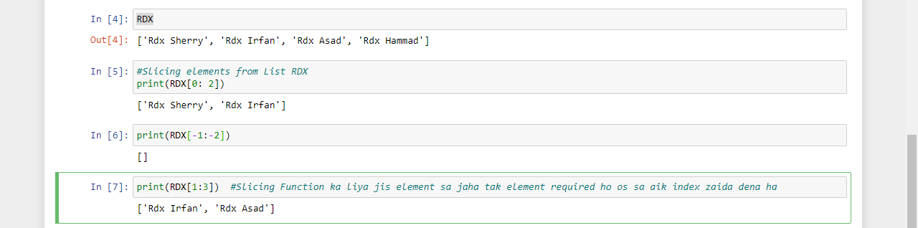
Reverse Slicing & Step Slicing:

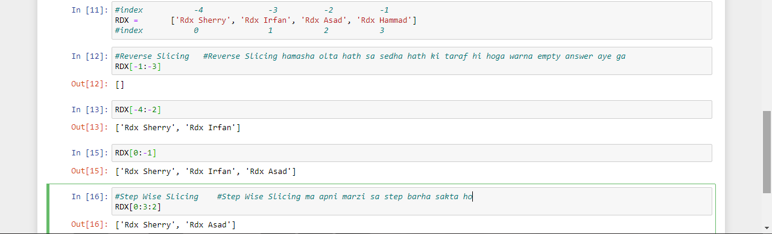
Deleting & Removing the value from list:
- Althrough both are synonyms but is a difference in Python how they are used.
- There are Cases when we exactly Know the index of value we need to delete, in such cases we use del keyword to delete the element.
Example

RDX = [1, 2, 3, 4, 5]

Del RDX[2]

Now if we check the contents of List RDX we will get the following output
[1, 3, 4, 5]

- In case if we know the value but we do not know the index of that vslue in list, we call remove function over the list identifier and pass the value to the function. Example

RDX = [1, 2, 3, 4, 5]

RDX.remove(1)

Now if we check the contents of list RDX we will get the following output

[1, 3, 4, 5]

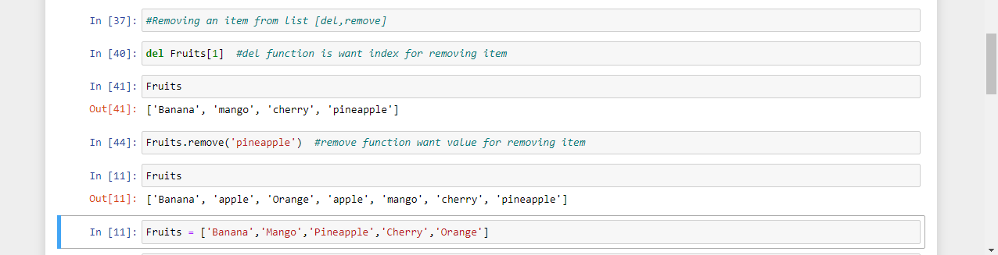

Popping Elements from the list:
- We know the index of the value to remove
- We want to remove the element at the end / tail of list

Example:

Arr = [1, 2, 4, 6, 7]
Arr.pop ( ) # will remove the value 7 from the end of list
Arr.pop (2) # will remove the value 4 from the index 2 of list

Note what is the Difference in del, remove and pop?
- del & remove function permanently delete the value or item but pop function remove temporarly the item or value and store in popped.

